Activity 6.3: Spirograph
Create a program that uses iteration to draw the following image For example:
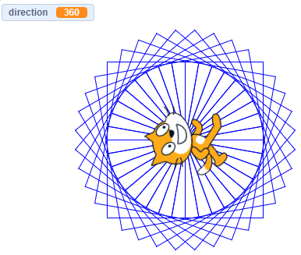

This image is made up of 36 squares. Each square is drawn at an angle 10° degrees different from the angle of the previous square.
HINTS
• Use iteration to get the cat to draw a single square.
• Create a variable that changes the direction of the square by 10 each time it is drawn.
• Use the ‘repeat’ block to repeat this process 36 times.
Don’t forget to screenshot your blocks and paste the screenshot into your evidence document.

Extension
Once the cat has drawn you a spirograph, can you program the cat to spin on the spot through 360° degrees and then say Mission complete!?
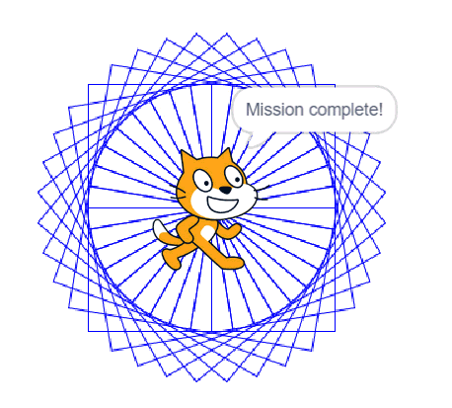
Remember to screenshot your blocks and paste the screenshot into your evidence document.

